QuPath - Practical 2

Objectives
- Refresher on Object Classification
- How to use the tools
- Feature selection

1. Using Machine Learning to Classify Cells
Classifying senescence is difficult and a single channel threshold is not sufficient. We’re going to train a machine learning classifier to use multiple cell measurements to make this classification decision.
- Return to one of our cultured cell images used in the previous practical
- Reset the cell classifications
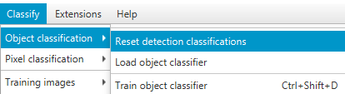

- We want to train an object classifier: Classify >> Object Classification >> Train Object Classifier
  - Set the object filter to “Cells”
  - Select “Live update”
  - This will not yet do anything, as you need to generate some training data

- Training data is generated using the Points tool
  - You are using this to select cells
  - Point size is purely for visualisation. It’s the position of the centre which is important.
- To be used to train the model, the points must have a class
  - Within the Points tool press “Add” twice,
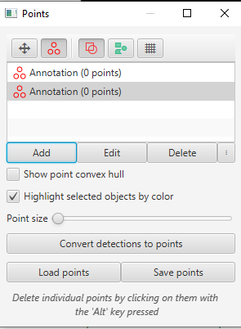
  - Then in the Annotations window, select the points annotations and a relevant classification, the press “Set Selected”
  - Do this for each collection of points, assigning them the two classifications (Senescent or Ignore)
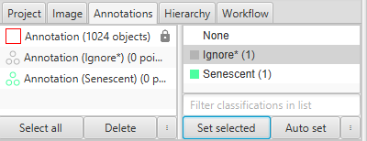
  - Select each points collection (and add points within a range of cells which should belong to the class assigned (Senescent cells are generally bigger and redder)
- Do this for both classes of points
- You will now begin to see the live prediction being made in the Train Object Classifier window.
- Within the Features drop down menu, choose selected measurements and press “Select” to view the options
  - This is where you choose features for a ML model (i.e. columns from the table)
  - It doesn’t matter what you choose, you may wish to see what works and what doesn’t.
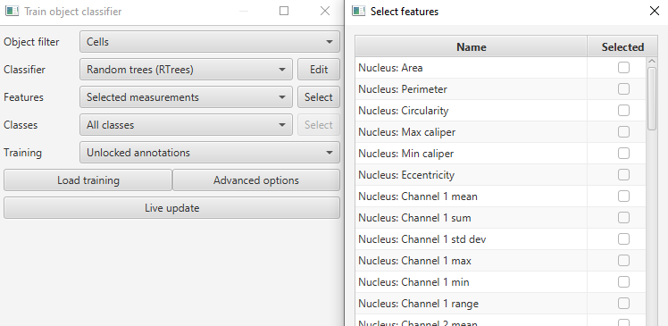
- Give the classifier a name and save it.

